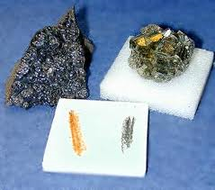
Physical Characteristics of Minerals

A mineral is an inorganic substance found naturally on the Earth’s crust. All minerals are crystals but not all crystals are minerals.

Inorganic means materials not containing carbon compounds other than carbon oxides
Crystals are solids formed of atoms arranged in a regular manner

Minerals can be characterised by their physical properties:

1. Colour: Explain how colour can be used to identify minerals. Colour can be helpful to identify different minerals because they come in many different colours.
Green and blue often indicate copper whilst red usually indicates iron.
Is colour a good way to identify minerals? Why? No, because the same mineral can come in many different colours, however it is helpful when used with other evidence.

2. Streak: This is the colour of the powdered mineral. This colour can be quite
different from the parent rock.
Explain how you test for streak. You drag the rock/mineral across a porcelain tile.
Is streak the same as colour? No

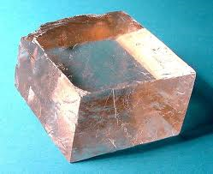
3. Cleavage: Explain what cleavage in minerals means. It means the tendency of a mineral to break along smooth planes. This is due to the bonding between molecules. Mica has one cleavage plane which breaks it into flat sheets. Iron pyrites (fool’s gold) has six which break it into cubic prisms.
Draw some examples of different forms of cleavage in minerals.

4. Magnetism: Explain what magnetism means. It means being attracted to a magnet.
How do you test for it? You test for it by holding the mineral near a magnet.

5. Lustre: Explain what lustre is. The appearance of a mineral in reflected light.
Describe three of the terms used to identify lustre. Eg earthy. Earthy means looking reddish brown colour like the dirt or earth. Metallic means looking like metal. Vitreous means looking like glass. Pearly means looking like pearl.

6. Crystalline Habit: Explain the crystalline habit of different mineral. Crystalline habit means the shape the crystals form such as, cubic, tabular, prismatic.
Draw three different crystal forms.

7. Hardness: Describe hardness of a mineral. The resistance of a mineral to scratching by other minerals.

Complete the Moh’s Hardness Scale:
1 | Talc | 6 | Orthoclase Feldspar
2 | Gypsum | 7 | Quartz
3 | Calcite | 8 | Topaz
4 | Fluorite | 9 | Corundum
5 | Apatite | 10 | Diamond

8. Specific Gravity: Explain specific gravity. Specific gravity is the ratio of the weight of a substance to that of an equal volume of water. Eg. gold has a specific gravity of 19.3. In other words, gold is 19.3 times heavier than an equal volume of water.



